Hobbywing Scooter BLE Protocol B-01.0.01
version | date | Modify the content | Reviser
01.0.01 | 2024-12-13 | First release | Li Yong


Version modification history
2024-12-13
directory
- Bluetooth service UUID........................................................................................................................................... 3
- Meter and APP communication........................................................................................................................................ 3
  - Meter Scheduled Reporting Script 0x00 Data Format........................................................................................... 3
  - Meter Scheduled Reporting Instruction Code 0x01 Data Format........................................................................................... 5
  - The app sends Bluetooth data to the meter................................................................................................................ 7
- Controller OTA upgrade....................................................................................................................................... 7
  - App Issue Instrument Commands........................................................................................................................... 7
  - Meter (host) and controller (slave) upgrade communication.............................................................................................. 8
- Meter OTA upgrade........................................................................................................................................... 8
  - BIN file for upgrading meters.................................................................................................................. 8
  - Instrument upgrade flow chart: ........................................................................................................................... 9
  - Read VCU firmware version information................................................................................................................ 10
  - Send upgrade package information............................................................................................................................. 11
  - Send the upgrade file................................................................................................................................. 11
  - Example of meter upgrade (without encryption):........................................................................................................... 12
- AT directive...................................................................................................................................................... 12
  - Datacom Connectivity Test .......................................................................................................................... 12
  - Bluetooth Broadcast Name Query and Settings............................................................................................................. 13
  - Application layer password verification............................................................................................................................. 13
  - Connecting to the Verification Password Setting Command................................................................................................................. 13 6 CRC16-MODBUS..................................................................................................................................... 14
1 Bluetooth service UUID

1.1 Transparent data transmission services
透传服务 UUID：0000f1f0-0000-1000-8000-00805f9b34fb 透传接收 UUID：0000f1f1-0000-1000-8000-00805f9b34fb（write）透传发送 U UID：0000f1f2-0000-1000-8000-00805f9b34fb（notify）
AT service
1.2
AT
Instruction service
UUID
：
0000
f2f0
-0000-1000-8000-00805f9b34
fb
UUID
：
0000
f2f1
-0000-1000-8000-00805f9b34
fb
（
write
）
UUID
：
0000
f2f2
-0000-1000-8000-00805f9b34
fb
（
notify
）
1.3
Instrument upgrade service
Upgrade services
UUID
：
F000FFC0-0451-4000-B000-00000000000000
Upgrade reception
UUID
：
F000FFC1-0451-4000-B000-00000000000000
Upgrade send
UUID
：
F000FFC2-0451-4000-B000-00000000000000
2
Meter and
APP
correspondence
2.1
The meter is reported regularly
Script
0
x
00
data format
serial number
Byte definition
Example
Content definition
remark
0
turban
0
xAB
1
Script
0
00
x
2
Total number of bytes in the frame
0
19
x
0x19=25
3
Motor direction
01
0
x
Take the value
1
~
0
1-
positive direction,
0-
Opposite direction
4
Gear
01
x
0
Take the value
~
3
0
1-
Indicates the current
2
File
5
Electricity
x
64
0
Take the value
0-100
0x64=100
Indicates electricity
measure
%
100
6
velocity
1
High bytes
x
0
27
Take the value
0-65535
0x2710=10000
Indicates electricity
machine
1
The speed is
km/h
10
or
mph
10
(Refer to the specific unit.)
Table below
bit6
Note)
7
velocity
1
Low bytes
x
10
0
8
velocity
2
High bytes
0
x
27
Take the value
0-65535
0x2710=10000
Indicates electricity
machine
2
The speed is
10
km/h
or
mph
10
(Refer to the specific unit.)
Table below
bit6
Note)
9
velocity
2
Low bytes
x
0
10
10
Voltage high bytes
0
x
00
0x0064=100
denote
10
V
，
AT reception
AT send
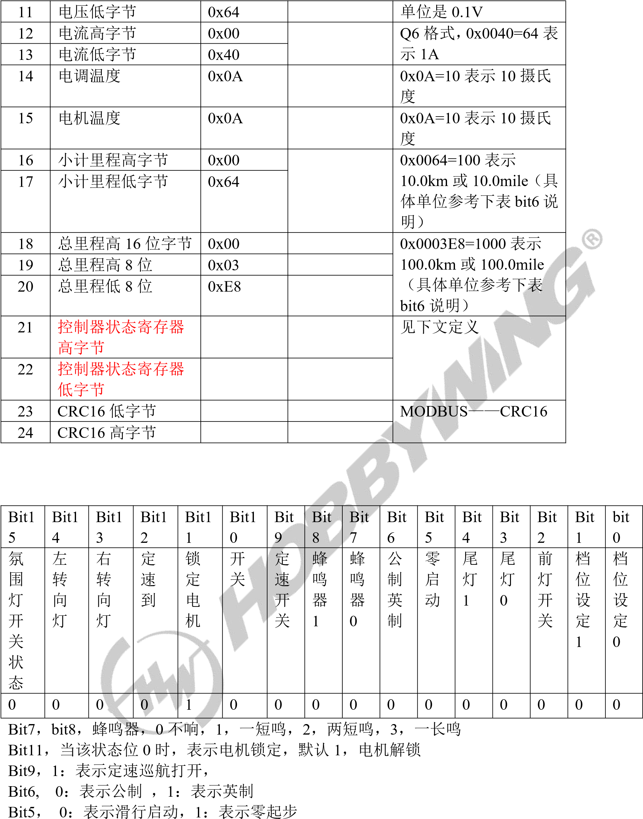Controller status registers:
Bit2, 1: Indicates that the headlights are on
Bit1, bit0, 0: energy saving, 1: normal, 2: movement

2.2 Instrument scheduled reporting instruction code 0x01 data format
serial number | Byte definition | Example | Content definition | remark
0 | turban | 0xAB
1 | Script | 0x01
2 | Total number of bytes in the frame | 0x19 |  | 0x19=25
3 | Entering cruise control allows the lowest speed | 0x03 |  | In the metric format, 3 is indicated  3KM/H, in imperial format 3 means 3MPH
4 | Maximum speed limit in energy saving mode | 0x0f |  | In metric format, 15 represents 15KM/H, in imperial system  15 under the format is indicated  15MPH
5 | Comfort mode maximum speed limit | 0x16 |  | In metric format, 22 represents 22KM/H, in imperial system  22 is indicated under the format  22MPH
6 | Sport mode maximum speed limit | 0x1f |  | In metric format, 31 represents 31KM/H, in imperial system  31 under the format is indicated  31MPH
7 | Not defined | 0x00
8 | Fault flag high byte | 0x00
9 | Fault flag low byte | 0x00
10 | panel selects High Byte | 0x00
11 | panel selects low bytes | 0x00
12 | Not defined | 0x00
13 | Not defined | 0x00
14 | Not defined | 0x00
15 | Not defined | 0x00
16 | Not defined | 0x00
17 | Not defined | 0x00
18 | Instrument software version number | 0x80 |  | Indicates 8025_01.00.01
19 | Instrument software version number | 0x25 |  | Indicates 8025_01.00.01
20 | Instrument software version number | 0x01 |  | Indicates 8025_01.00.01
21 | Instrument software version number | 0x00 |  | Indicates 8025_01.00.01
22 | Instrument software version number | 0x01 |  | Indicates 8025_01.00.01
23 | CRC16 low bytes |  |  | MODBUS——CRC16
24 | CRC16 High Bytes |  |  | MODBUS——CRC16
Fault flags:
Bit1 5 | Bit1 4 | Bit1 3 | Bit1 2 | Bit1 1 | Bit1 0 | Bit 9 | Bit 8 | Bit 7 | Bit 6 | Bit 5 | Bit 4 | Bit 3 | Bit 2 | Bit 1 | bit  0
Fault warning enabled bit |  |  |  | The throttle is not reset to F2 | Brake finger paddle not reset F1 | Op amp bias E9 |  | Hall Fault E7 |  |  | Overcurrent E4 | Communication disconnect E3 | Throttle fault E2 | Brake failure E1
1 | 0 | 0 | 0 | 0 | 0 | 0 | 0 | 0 | 0 | 0 | 0 | 0 | 0 | 0 | 0
Panel Selection:
B
it1
5
B
it1
4
B
it1
3
B
it1
2
B
it1
1
B
it1
0
B
it
9
B
it
8
B
it
7
B
it
6
B
it
5
B
it
4
B
it
3
B
it
2
B
it
1
bit
0
quick
degree
single
bit
choose
choose
0-
m/
h
1-
10
0
m/
h
BM
S
RG
B
face
board
MP
3
face
board
S
N
yard
face
board
0
0
0
0
0
0
0
0
0
0
0
0
0
0
0
0
0--
Hide the corresponding panel function
1-
-
Load the corresponding panel function
Bit12
: Speed unit selection
m/h
1-100
0-m/h

2.3 The app sends Bluetooth data to the meter
serial number | Byte definition | Example | remark
0 | turban | 0xAB
1 | Script | 0
2 | Total bytes | 10 | Total number of bytes in the frame
3 | Data 1 | 0 | button definition
4 | Data 2 | 0 | See description below
5 | Data 3 | 0 | See description below
6 | Data 4 | 0 | See description below
7 | Data 5 | 0 | See description below
8 | CRC Low Bytes | CRC
9 | CRC High Bytes | CRC
Data 1, button definition end transmission:
B
it7
B
it6
B
it5
B
it4
B
it3
B
it2
B
it1
bit0
Lock button
Metric Imperial system
Convert button
Zero start press
button
Cruise control
button
Ambient lighting
switch
Headlights press
button
Gear setting
button
1
Gear setting
decide
button
0
0
0
0
0
0
0
0
0
data
2
, cruise control minimum speed limit,
Unsigned
char
format
In the metric format,
1
denote
KM/H,
1
In imperial format
1
denote
MPH
1
data
3
, in energy-saving mode, maximum speed limit,
Unsigned
char
format, in the metric format,
1
denote
1
KM/H,
In imperial format
1
denote
1
MPH
data
4
, in comfort mode, maximum speed limit,
Unsigned
char
format, in the metric format,
1
denote
1
KM/H,
In imperial format
1
denote
1
MPH
data
5
, in sport mode, maximum speed limit,
Unsigned
char
format, in the metric format,
1
denote
1
KM/H,
In imperial format
1
denote
1
MPH
3
controller
FATHER
upgrade
3.1
App
Issue instrument instructions
Start transmitting transmission
:
A5
00
FF
00
00
00
00
5
A
A5 FF 00 00 00 00 00 5A
Start consolidating:
A5 01 FE 00 00 00 00 5A End the package:
A5 FE 01 00 00 00 00 5A
Connection signal:
A5 02 FD 5A
After the app sends the connection command, the meter starts uploading data regularly

3.2 Instrument (host) and controller (slave) upgrade communication
1) Host send connection: 01 51 C1 DC Slave answer: 01 51 C1 DC
CRCL
CRCH
51
CRCL
CRCH
2
）
Host sends erase
：
01
52
81
DD
Slave erase successfully answers:
01
52
81
DD
Failed answer:
01
D2
80
7
D
CRCL
CRCH
52
CRCL
CRCH
3
) host
Read the device version information
：
01
07
00
00
00
10
20
06
6
F
Cluster address
command code
address
H
address
L
Number of registers
H
Number of registers
L
Number of bytes
CRCL
CRCH
07
00
00
00
10
20
CRCL
CRCH
4
) hosts send upgrade packages
data
(The effective data length is variable.)
，
General recommendations
1024
）
Cluster address
command code
pack
number
H
pack
number
L
byte
number
H
byte
number
L
Within the data
appearance
1
Within the data
appearance
2
Within the data
appearance
3
50
00
00
Number of bytes
H
Number of bytes
L
XX
XX
XX
Data content
4
Data content
5
Data content
6
Data content
7
Data content
8
Data content
9
Data content
10
XX
XX
XX
XX
XX
XX
Within the data
appearance
11
Within the data
appearance
12
Within the data
appearance
13
Within the data
appearance
14
Within the data
appearance
15
Within the data
appearance
16
CRCL
XX
XX
XX
XX
XX
CRCL
4
appearance
FATHER
upgrade
Cluster address command code
01
Cluster address command code
01
01
01
XX
CRCH XX CRCH

4.1 Upgrade the BIN file for the instrument
The upgrade file is a .bin file, where the first 16 bytes of the bin file are the upgrade firmware information, and the first 16 bytes are the upgrade data.
The following image shows the first part of the bin file
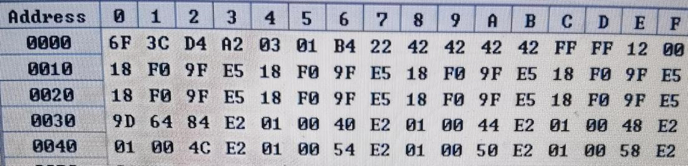
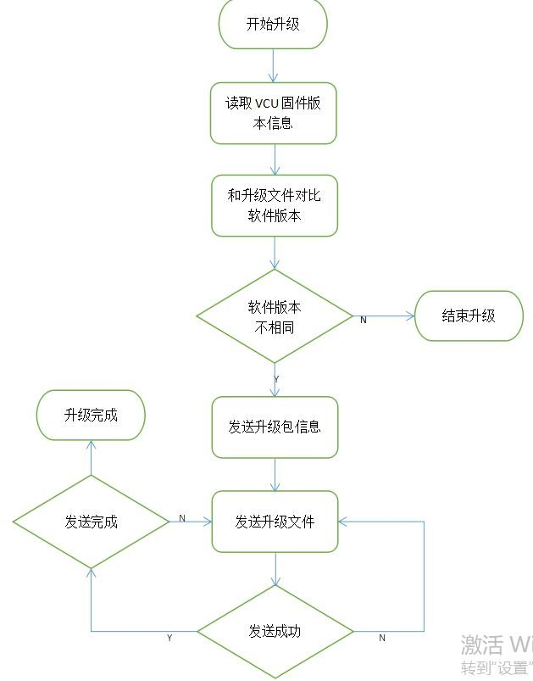
former
16
The byte parse looks like this
(
Low bytes are in front
)
：
Byte0-Byte3
Upgrade the data checkpoints
Byte4-Byte5
To be upgraded
vcu
Version number
(Data.)
03
0
x
0
x
01
Corresponding version number
V1.03
）
Byte6-Byte7
Upgrade file length, units: words
(Data.)
0
xB
4
0
x
22
Corresponding length
4
0
x22B
）
Byte8-Byte11
Upgrade Type
(Data.)
0
x
42
0
x
42
0
x
42
0
x
42
Upgrade Instrument Program)
Byte12-Byte13
retain
Byte14-Byte15
Bluetooth protocol stack version
(Data.)
0
x
12
0
x
00
Corresponding version number
V0.12
）
App
You need to check whether the version number of the instrument to be upgraded is different from the current version number of the instrument
，
If the version number is the same, the meter will not be upgraded
。
4.2
Instrument upgrade flow chart:

4.3 Read VCU firmware version information
App发送: UUID:f000ffc1-0451-4000-b000-00000000000000
serial number | Byte definition | Example
0 | directives | 0x00
VCU回复： UUID：f000ffc1-0451-4000-b000-000000000000
serial number
Byte definition
Example
0
VCU
The version number is low
8
bit
0
x1A
1
VCU
The version number is high
8
bit
0
00
x
2
The firmware package length is low bytes
xB
4
0
3
The length of the firmware package is high bytes
22
0
x
4
Uid0
42
0
x
5
Uid1
0
42
x
6
Uid2
0
42
x
7
Uid3
x
42
0
8
WAS
The protocol stack version is low
8
bit
x
12
0
9
WAS
The protocol stack version is high
8
bit
0
00
x
App
Can be used only
vcu
version, other data can be ignored.

4.4 Sending Upgrade Package Information
The content sent is the first 16 bytes of the upgrade package
App发送: f000ffc1-0451-4000-b000-000000000000
VCU replied:
serial number
Byte definition
Example
0
Firmware package verification bytes
X6F
0
1
Firmware package verification bytes
0
x
C
3
2
Firmware package verification bytes
0
xD
4
3
Firmware package verification bytes
0
xA
2
4
VCU
The version number is low
8
bit
0
03
x
5
VCU
The version number is high
8
bit
x
0
01
6
The firmware package length is low bytes
xB
4
0
7
The length of the firmware package is high bytes
x
22
0
8
Uid0
0
42
x
9
Uid1
x
42
0
10
Uid2
x
42
0
11
Uid3
x
42
0
12
retain
0
xFF
13
retain
0
xFF
14
WAS
The protocol stack version is low
8
bit
0
12
x
15
WAS
The protocol stack version is high
8
bit
0
00
x
F000FFC2-0451-4000-B000-00000000000000
serial number
Byte definition
Example
0
The package number is low
8
bit
0
00
x
1
The package number is high
8
bit
x
0
00
Note
VCU
The reply is passed
FFC2
4.5
Send the upgrade file
App发送: f000ffc2-0451-4000-b000-000000000000
The app needs to split the entire upgrade file into 16 bytes per package and send it to VCU, and the package number needs to be automatically added to 1, and the app can be sent at intervals of 10ms per package
serial number | Byte definition | Example
0 | The package number is 8 digits lower | 0x00
1 | The bag number is 8 digits higher | 0x00
2-17 | Upgrade data 16 bytes
VCU reply: f000ffc2-0451-4000-b000-0000000000000
Only the VCU will reply if the data is received incorrectly The reply content is the package number, and the app needs to continue sending it down from the received package number after receiving the reply
serial number | Byte definition | Example
0 | The package number is 8 digits lower | 0x##
1 | The bag number is 8 digits higher | 0x##

4.6 Example of Meter Upgrade:
5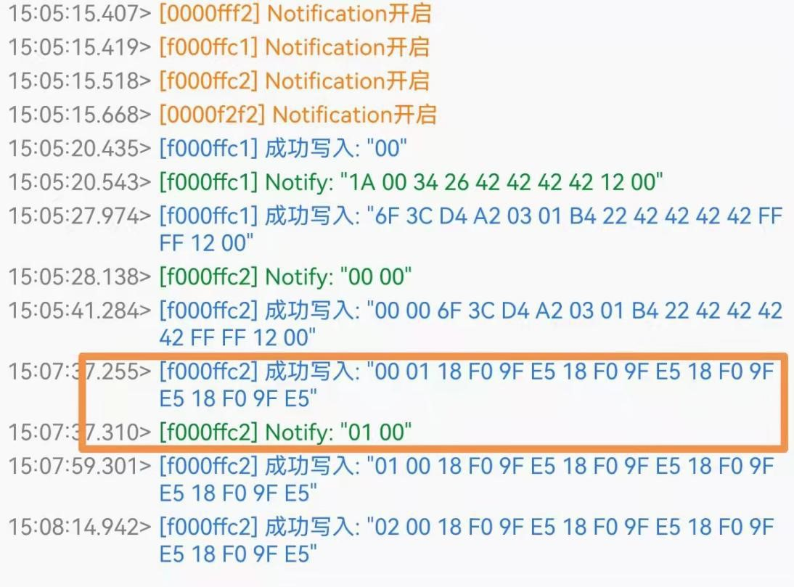 AT Instructions
Inside the box
App
The sending format is incorrect
vcu
The package number will be replied to and reminded
app
The package number is required
0
x
01
0
x
00
data.
5.1
Datacom connectivity test
This instruction is used to judge whether the Bluetooth module is working properly, and the processor receives the response and considers that the communication between devices is normal and the Bluetooth module can be used normally.
directives | Response |  | parameter
AT+ | OK+ | not

5.2 Bluetooth Broadcast Name Query and Setting
directives | Response | parameter
查询：AT+NAME? | OK+NAME:Para | Para: Module name  Up to 11 characters are allowed, pack
Set up:  AT+NAME[For] | OK+NAME:Para | 括字母、数字、下划线默认 Para=HW_ZAxx
Illustrate:
5.3
Application-layer password authentication
1
: This instruction is used for password authentication (service) when Bluetooth is connected
uuid
0
xF2F
0
）。
2
：
while
APP
When the password needs to be verified
，
This instruction is required to verify the identity
;
When the module is connected to the module
，
The host will automatically get in
Verification
。
The fixed password authentication time is
10
s
，
That is, after the connection
10
s
You must enter the correct password within that time to stay connected
，
5.4
Connect the Verification Password Setting Command
Send
AT+PWDM[XXXXXX]
XXXXXX
It is a six-digit number
Reply
0
K+PWDM:XXXXXX
directives
Response
parameter
Set up:
AT+PWD[Para]
Verification Successful:
OK+PWD:Y
Verification failed:
OK+PWD:N
For:
password
-6
Digits
Otherwise disconnect.
6 CRC16-MODBUS
/*****************************************************************************
@func :Calculate CRC16-MODBUS
@poly :8005(x16+x15+x2+1)
@init :0xFFFF
@xorout :0x0000
@refin :yes @refout :yes
*****************************************************************************/ uint8_t CRCH[] = {
0x00,0xC1,0x81,0x40,0x01,0xC0,0x80,0x41,0x01,0xC0,0x80,0x41,0x00,0xC1,0x81, 0x40,0x01,0xC0,0x80,0x41,0x00,0xC1,0x81,0x40,0x00,0xC1,0x81,0x40,0x01,0xC0,
0x80,0x41,0x01,0xC0,0x80,0x41,0x00,0xC1,0x81,0x40,0x00,0xC1,0x81,0x40,0x01,
0xC0,0x80,0x41,0x00,0xC1,0x81,0x40,0x01,0xC0,0x80,0x41,0x01,0xC0,0x80,0x41, 0x00,0xC1,0x81,0x40,0x01,0xC0,0x80,0x41,0x00,0xC1,0x81,0x40,0x00,0xC1,0x81, 0x40,0x01,0xC0,0x80,0x41,0x00,0xC1,0x81,0x40,0x01,0xC0,0x80,0x41,0x01,0xC0,
0x80,0x41,0x00,0xC1,0x81,0x40,0x00,0xC1,0x81,0x40,0x01,0xC0,0x80,0x41,0x01,
0xC0,0x80,0x41,0x00,0xC1,0x81,0x40,0x01,0xC0,0x80,0x41,0x00,0xC1,0x81,0x40, 0x00,0xC1,0x81,0x40,0x01,0xC0,0x80,0x41,0x01,0xC0,0x80,0x41,0x00,0xC1,0x81, 0x40,0x00,0xC1,0x81,0x40,0x01,0xC0,0x80,0x41,0x00,0xC1,0x81,0x40,0x01,0xC0,
0x80,0x41,0x01,0xC0,0x80,0x41,0x00,0xC1,0x81,0x40,0x00,0xC1,0x81,0x40,0x01,
0xC0,0x80,0x41,0x01,0xC0,0x80,0x41,0x00,0xC1,0x81,0x40,0x01,0xC0,0x80,0x41, 0x00,0xC1,0x81,0x40,0x00,0xC1,0x81,0x40,0x01,0xC0,0x80,0x41,0x00,0xC1,0x81, 0x40,0x01,0xC0,0x80,0x41,0x01,0xC0,0x80,0x41,0x00,0xC1,0x81,0x40,0x01,0xC0,
0x80,0x41,0x00,0xC1,0x81,0x40,0x00,0xC1,0x81,0x40,0x01,0xC0,0x80,0x41,0x01,
0xC0,0x80,0x41,0x00,0xC1,0x81,0x40,0x00,0xC1,0x81,0x40,0x01,0xC0,0x80,0x41, 0x00,0xC1,0x81,0x40,0x01,0xC0,0x80,0x41,0x01,0xC0,0x80,0x41,0x00,0xC1,0x81, 0x40
};
uint8_t CRCL[] = {
0x00,0xC0,0xC1,0x01,0xC3,0x03,0x02,0xC2,0xC6,0x06,0x07,0xC7,0x05,0xC5,0xC4,
0x04,0xCC,0x0C,0x0D,0xCD,0x0F,0xCF,0xCE,0x0E,0x0A,0xCA,0xCB,0x0B,0xC9,0x09, 0x08,0xC8,0xD8,0x18,0x19,0xD9,0x1B,0xDB,0xDA,0x1A,0x1E,0xDE,0xDF,0x1F,0xDD,
0x1D,0x1C,0xDC,0x14,0xD4,0xD5,0x15,0xD7,0x17,0x16,0xD6,0xD2,0x12,0x13,0xD3,
0x11,0xD1,0xD0,0x10,0xF0,0x30,0x31,0xF1,0x33,0xF3,0xF2,0x32,0x36,0xF6,0xF7,
0x37,0xF5,0x35,0x34,0xF4,0x3C,0xFC,0xFD,0x3D,0xFF,0x3F,0x3E,0xFE,0xFA,0x3A,0x3B,0xFB,0x39,0xF9,0xF8,0x38,0x28,0xE8,0xE9,0x29,0xEB,0x2B,0x2A,0xEA,0xEE,
0x2E,0x2F,0xEF,0x2D,0xED,0xEC,0x2C,0xE4,0x24,0x25,0xE5,0x27,0xE7,0xE6,0x26,
0x22,0xE2,0xE3,0x23,0xE1,0x21,0x20,0xE0,0xA0,0x60,0x61,0xA1,0x63,0xA3,0xA2,
0x62,0x66,0xA6,0xA7,0x67,0xA5,0x65,0x64,0xA4,0x6C,0xAC,0xAD,0x6D,0xAF,0x6F,
0x6E,0xAE,0xAA,0x6A,0x6B,0xAB,0x69,0xA9,0xA8,0x68,0x78,0xB8,0xB9,0x79,0xBB,
0
x7B,0x7A,0xBA,0xBE,0x7E,0x7F,0xBF,0x7D,0xBD,0xBC,0x7C,0xB4,0x74,0x75,0xB5,
0
x77,0xB7,0xB6,0x76,0x72,0xB2,0xB3,0x73,0xB1,0x71,0x70,0xB0,0x50,0x90,0x91,
0
x51,0x93,0x53,0x52,0x92,0x96,0x56,0x57,0x97,0x55,0x95,0x94,0x54,0x9C,0x5C,
0
x5D, 0x9D, 0x5F, 0x9F, 0x9E 0x9F, 0x5E 0x5A, 0x5A 0x9A, 0x9B, 0x5B, 0x99 0x59, 0x58 0x98, 0x98, 0x88,
0
x48,0x49, 0x89, 0x4B 0x8B, 0x8A 0x4A, 0x4E, 0x4E, 0x4F 0x8F 0x8E, 0x8D, 0x4D 0x8D, 0x4C, 0x8C, and 0x8C.
0
x44,0x84,0x85,0x45,0x87,0x47,0x46,0x86,0x82,0x42,0x43,0x83,0x41,0x81,0x80,
0
x
40
}
;
uint16_t
CalculateCRC16(uint8_t
const
*msgPtr,
u32
msgLen)
{
uint8_t
crcHigh
=
0
xFF;
uint8_t
crcLow
=
0
xFF;
uint8_t
index;
while
(
msgLen
--)
{
index
=
crcLow
^
msgPtr++));
(*(
crcLow
=
crcHigh
^
CRCH[index];
crcHigh
=
CRCL[index];
}
return
(
uint16_t)((uint16_t)(crcHigh
<<8)
|
crcLow);
}

